**Metodický materiál - Křížovka**

**Název:** Periodická soustava prvků

**Předmět:** Základy chemie

**Využití pro ročník:** 1. ročník maturitních a učebních oborů SŠ

**Časový odhad:** 20 – 30 min

**Anotace**: Žáci se seznámí s chemickými prvky – značkou, českým a latinským názvem.

**Použité metody:** Didaktické hry a metoda slovní

**Pomůcky:** Přiložený materiál a periodickou tabulku prvků.

**Popis postupu využití:** Žáci se nejdříve seznámí s periodickou soustavou prvků a následně podle ní vyplní křížovku. Kombinování českých a latinských názvů pomůže jejich zapamatování.

**Odkazy, zdroje:** <https://www.albatrosmedia.cz/tituly/27722720/periodicka-tabulka-prvku/>

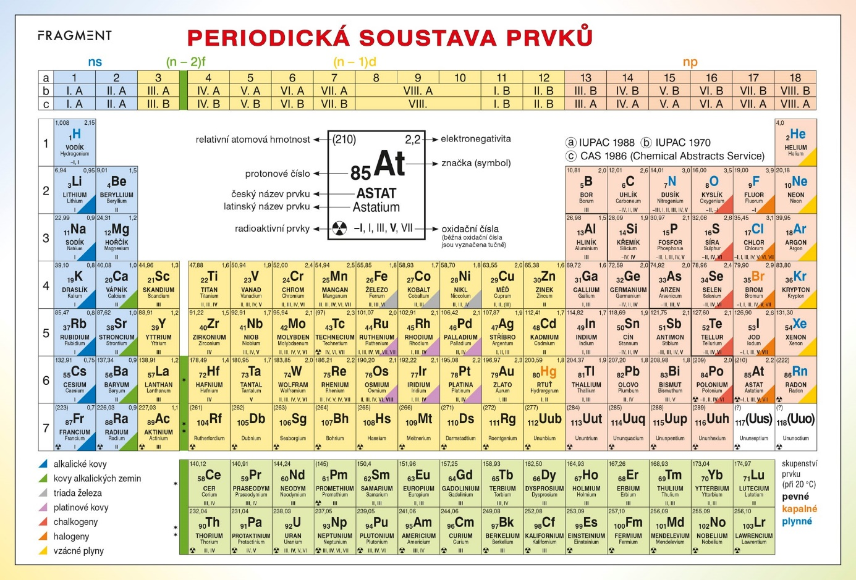

**Do křížovky doplňte latinské názvy těchto prvků:**

1 - Fosfor

2 - Stříbro

3 - Rtuť

4 - Platina

5 - Uhlík

6 - Kadmium

7 - Helium

8 - Vápník

9 - Draslík

10 – Zlato

11 - Síra

12 - Uhlík

13 - Zinek

14 - Hořčík

15 - Plutonium

16 - Radon

17 - Vanad

18 - Titan

19 - Měď

20 - Železo

21 - Vanad

22 - Krypton

23 - Draslík

|  |  |  |  |  |  |  |  |  |  |  |  |  |  |  |
| --- | --- | --- | --- | --- | --- | --- | --- | --- | --- | --- | --- | --- | --- | --- |
| 1 |  |  |  |  |  |  |  |  |  |  |  |  |  |  |
| 2 |  |  |  |  |  |  |  |  |  |  |  |  |  |  |
| 3 |  |  |  |  |  |  |  |  |  |  |  |  |  |  |
| 4 |  |  |  |  |  |  |  |  |  |  |  |  |  |  |
| 5 |  |  |  |  |  |  |  |  |  |  |  |  |  |  |
| 6 |  |  |  |  |  |  |  |  |  |  |  |  |  |  |
| 7 |  |  |  |  |  |  |  |  |  |  |  |  |  |  |
| 8 |  |  |  |  |  |  |  |  |  |  |  |  |  |  |
| 9 |  |  |  |  |  |  |  |  |  |  |  |  |  |  |
| 10 |  |  |  |  |  |  |  |  |  |  |  |  |  |  |
| 11 |  |  |  |  |  |  |  |  |  |  |  |  |  |  |
| 12 |  |  |  |  |  |  |  |  |  |  |  |  |  |  |
| 13 |  |  |  |  |  |  |  |  |  |  |  |  |  |  |
| 14 |  |  |  |  |  |  |  |  |  |  |  |  |  |  |
| 15 |  |  |  |  |  |  |  |  |  |  |  |  |  |  |
| 16 |  |  |  |  |  |  |  |  |  |  |  |  |  |  |
| 17 |  |  |  |  |  |  |  |  |  |  |  |  |  |  |
| 18 |  |  |  |  |  |  |  |  |  |  |  |  |  |  |
| 19 |  |  |  |  |  |  |  |  |  |  |  |  |  |  |
| 20 |  |  |  |  |  |  |  |  |  |  |  |  |  |  |
| 21 |  |  |  |  |  |  |  |  |  |  |  |  |  |  |
| 22 |  |  |  |  |  |  |  |  |  |  |  |  |  |  |
| 23 |  |  |  |  |  |  |  |  |  |  |  |  |  |  |

|  |  |  |  |  |  |  |  |  |  |  |  |  |  |  |
| --- | --- | --- | --- | --- | --- | --- | --- | --- | --- | --- | --- | --- | --- | --- |
| 1 |  |  | p | h | o | s | P | h | o | r | u | s |  |  |
| 2 |  |  |  | a | r | g | e | n | t | u | m |  |  |  |
| 3 |  | h | y | d | r | a | r | g | y | r | u | m |  |  |
| 4 |  |  | p | l | a | t | i | n | u | m |  |  |  |  |
| 5 |  |  | c | a | r | b | o | n | e | u | m |  |  |  |
| 6 |  |  |  |  | c | a | d | m | i | u | m |  |  |  |
| 7 |  |  |  | h | e | l | i | u | m |  |  |  |  |  |
| 8 |  |  |  | c | a | l | c | i | u | m |  |  |  |  |
| 9 |  |  |  |  |  |  | k | a | l | i | u | m |  |  |
| 10 |  |  |  |  |  |  | a | u | r | u | m |  |  |  |
| 11 |  |  |  |  |  |  | s | u | l | p | h | u | r |  |
| 12 |  |  | c | a | r | b | o | n | e | u | m |  |  |  |
| 13 |  |  | z | i | n | c | u | m |  |  |  |  |  |  |
| 14 |  | m | a | g | n | e | s | i | u | m |  |  |  |  |
| 15 |  |  |  | p | l | u | t | o | n | i | u | m |  |  |
| 16 |  |  |  |  |  | r | a | d | o | n |  |  |  |  |
| 17 |  |  |  |  |  |  | v | a | n | a | d | i | u | m |
| 18 |  |  |  | t | i | t | a | n | i | u | m |  |  |  |
| 19 |  |  |  |  | c | u | p | r | u | m |  |  |  |  |
| 20 |  |  |  | f | e | r | r | u | m |  |  |  |  |  |
| 21 |  |  |  |  |  |  | v | a | n | a | d | i | u | m |
| 22 |  |  |  |  |  |  | k | r | y | p | t | o | n |  |
| 23 |  |  | k | a | l | i | u | m |  |  |  |  |  |  |